Stanley G. Thompson-
a chemist's chemist
Glenn T. Seaborg

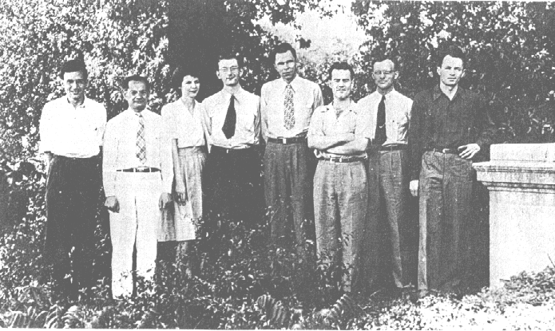
The UCLA Gang, Chicago, July 1944. Left to right: Leonard Katzin, Zene Jasaitis, Nathalie and Harlan Baumbach, Glenn Seaborg, Stanley Thompson, Leonard Dreher, Fred Albaugh
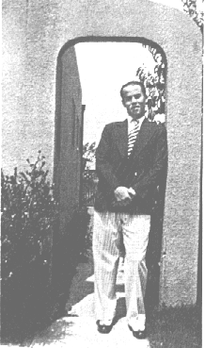

In looking back at the discovery of transuranium elements the name Stanley G. Thompson stands out. When he died (July 16, 1976), chemistry lost an extraordinary practitioner, and I lost a lifelong friend.
At the age of 64, Stan lost his courageous bout with cancer. But throughout his career he was a "chemist's chemist;" a possessor of "chemisches Gefuhl" to a unique extent, inventive and meticulous in his work. He avoided the administrative route to fame, preferring to work in the laboratory. The results were an impressive record of discovery and of help to the careers of young co-workers. He was an internationalist whose laboratory served as a home to scientists from many countries. His radiochemical research during World War II rivals in importance the isolation of radium by Pierre and Marie Curie, and his leadership in the discovery of five transuranium elements must rank as among the leading chemical accomplishments of his time.
I met Stan when we were both 13-year-old entering freshmen at David Starr Jordan High School in the Watts district of Los Angeles, and we immediately formed an attachment. He was interested in science from the beginning; I took no courses in science until my junior year, and we became classmates in a small chemistry class. Our inspiring teacher, Dwight Logan Reid, motivated both of us to choose chemistry as a career, although Stan was al-
Thompson at time of his graduation from Jordan High School, Watts, California, June 1929

ready strongly inclined in that direction. He led the chemistry class in academic standing.
We both entered tuition-free UCLA the following fall as chemistry majors, commuting together the 20-25 miles each way in various jalopies, including Stan's model A touring car. As early as his sophomore year, he was doing research to help improve some of the experiments in the quantitative analysis c6urse. His inherent experimental ability manifested itself early and throughout his undergraduate career at UCLA.

getting started
His first position after getting his A.B. in chemistry from UCLA in 1934 was as a chemist in the Richmond Laboratory of Standard Oil of California. As fate would have it, I started my graduate work at nearby Berkeley at the same time. During the following years, we saw a good deal of each other. We visited many of California's scenic spots and lived as roommates for awhile.
The girl Stan introduced me to in the fall of '38 had obviously made a tremendous impact on him. His marriage to her followed very soon. In November Alice Isobel Smith became Mrs. Thompson and from then on she served as his helpmate and a constant source of strength and comfort.
When I moved to the wartime Metallurgical Laboratory at the University of Chicago in 1942, I naturally turned to Stan as a chemist who I knew could make crucial contributions to the challenging problems that faced us. We had the responsibility for devising a chemical process, to be operated by remote control, for separating plutonium from the enormous quantities of radioactive fission products and uranium, with which it would be associated following its production in chain-reacting piles. I asked him to join me at Chicago, and he immediately agreed. (I later lured many other of my UCLA classmates to Chicago)
My hunch that his intuitive and imaginative abilities and practical experience would pay off was confirmed even sooner than I expected. Within three months he conceived and tested experimentally the Bismuth Phosphate Process, which was put into successful operation at Hanford, Washington, within two years. This process represented the largest scale-up in history, a chemical and technological achievement of enormous proportions. In the course of this very successful development, about whose potential success much skepticism was expressed, he directed the training of hundreds of chemists. He, Alice and their young daughter Ruth Ann moved to Richland, Washington, so that he could be present during the critical period in 1944-45 when the chemical extraction plant went into operation and yielded the first batches of plutonium that were shipped to the laboratory at Los Alamos, New Mexico. At the Metallurgical Laboratory we worked a six-day schedule, with meetings many evenings, each week. Thus when weather permitted, or even when it really didn't, we

Notable Accomplishments
of Stanley G. Thompson
1. Bismuth phosphate process for separating plutonium from
uranium and fission products. December 1942-December1944. See Progress in Nuclear Energy, Series III, Process Chemistry, Vol. I, 163 (Pergamon Press, London, 1956).
2. Alpha decay In rare earth isotopes. September 1949. See Phys.
Rev., 76, 1406(1949).
3. Berkelium (Element 97). December 1949. See Phys. Rev.,
77, 838 (1950).
4. Califomium (Element 98). February 1950. See Phys. Rev.,
78, 298 (1950).
5. EinsteInium (Element 99). December 1952. See Phys. Rev.,
99, 1048 (1955).
6. Fermium (Element 100). January 1953. See Phys. Rev., 99,
1048 (1955).
7. Nuclear subshell at N = 152. May 1954. See Phys. Rev.,
95, 293 (1954).
8. Nuclear thermodynamics of the heaviest elements.
1950-1955. See J. lnorg. Nucl. Chem., 1, 3 (1955).
9. Mendelevium (Element 101). April 1955. See Phys. Rev.,
98,1518 (1955).
10. First isolation of berkelium and californium. 1958. See
Proceedings of the Second United Nations international
Conference on the Peaceful Uses of Atomic Energy, Sep-
tember 1-13, 1958, Geneva P1825, Vol 28, 346 (UnIted
Nations, Geneva, 1958).
11 . Non-destructive energy dispersive x-ray fluorescence analysis. 1965-1968. See Science, 151, 562 (1966).
12. Spontaneous fission properties of californium-252.
195~1973. See Can. J. Phys., 41, 2080 (1963).
13. Search for superheavy elements in nature. 1969-1972. See Phys. Rev. C, 6, 1348 (1972).
14. Heavy ion reactions. 197~1975. See Phys. Lett., 58B, 31
(1975).

Students of
Stanley G. Thompson
Reinhard Brandt (1960-62)
Donald S. Burnett (1960-63)
Alfred Chetham-Strode, Jr. (1953-56)
Janis Bueling Dairiki (1960-61)
John Gilmore (1957-60)
Peter R. Gray (1953-55)
Eldon L. Haines (1959-62)
Gary H. Higgins (1949-52)
Richard W. Hoff (1950-54)
E. Kenneth Hulet (1949-53)
Frank Plasil (1961-65)
Richard P. Schmitt (1972-75)
Joseph P Surls, Jr. (1951-56)
Rand L Watson (1963-61)
Jerry B. Wilhelmy (1965-69)

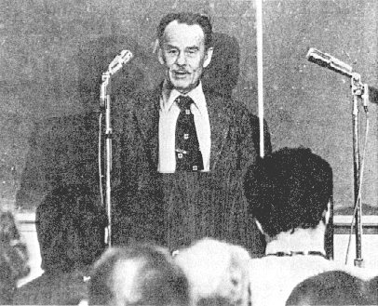
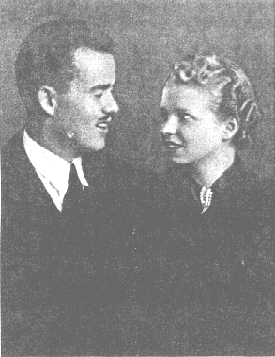

Stanley and Alice Thompson, wedding picture, November 1938

Thompson at the Symposium commemorating the 25th anniversary of the discovery of berkelium and californium, Lawrence Berkeley Laboratory, 1975

found some recreation in our Sunday golf. Stan and I played some torrid matches with honors fairly evenly divided.
Stan returned from Hanford to the Metallurgical Laboratory in spring, 1945, and spent a year laying the groundwork for his subsequent Berkeley work in the discovery of transuranium elements. He joined the Radiation Laboratory (as it was called then) in 1946 and completed his Ph.D. thesis within two years. He hardly needed to prove his research ability and he performed the required course work with distinction.
A short time later, during the period December 1949 to February 1950, he led a research team on the synthesis and identification of berkelium and californium, the trans-uranium elements with atomic numbers 97 and 98. He also participated, in 1958, with the late Burris B. Cunningham, in the first isolation of these elements in weighable quantities.
A name was given to element 97 immediately; in fact, you might say that a name had been chosen even before it was discovered. According to the actinide concept, element 97 is the chemical homolog of terbium, which was named after the Swedish town of Ytterby. So the name "berkelium" after the city of Berkeley practically leaped out. However, the mayor of Berkeley displayed a complete lack of interest when he was called with the glad tidings. Stan and Al Ghiorso wanted to give berkelium the chemical symbol Bm, because it had been such a stinker in resisting identification for so long, but cooler heads prevailed and the symbol Bk was finally accepted by the scientific world.
The name did not go uncontested. Two Soviet scientists, A. P. Znoyko and V.1. Semishin, in an article entitled "The Problem of Elements 97 and 98," published in Dok

lady Akademii Nauk, USSR (Novaya Seriya, Vol. XXIV, No.5, 1950, pp 917-921), claimed the right to name element 97 because they had predicted its radioactive decay properties two years before its discovery using their Mendeleev periodic system of atomic nuclei. They suggested that it therefore be given the name "mendelevium" (symbol Md). Perhaps these investigators were satisfied some five years later when the name "mendelevium" was ascribed to element 101, on the sounder basis of recognizing Mendeleev's contribution.

Elementary spelling
More official communications concerned the spelling and pronunciation of "berkelium:" Stan and his co-workers preferred to keep the second "e" in the spelling-a faithful reflection of the tie-in to the name of the city Berkeley. The nomenclature committee of the National Research Council suggested dropping the second e, thus spelling and pronouncing it "berk'lium." As we know, the spelling remained with the inclusion of the second e, i.e., "berkelium," but the pronunciation varies, with berk'lium prominent in the United States (as we prefer) and ber-ke-lium used more often in Europe.
Naming element 98 was not as straightforward. According to the actinide concept, element 98 is the chemical homolog of the lanthanide element, dysprosium. A little research showed that the name "dysprosium" was based on the Greek word "dysprositos" meaning "hard to get at." Although element 98 was hard to get at, in the sense that work had been going on toward its synthesis and identification for some three years, there was trouble finding an analogous name.
The group, therefore, toyed with a rather long list of possibilities. We found a handwritten list of names in

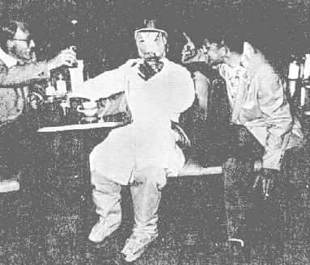
Thompson in effigy with Bernard Harvey and Bernie Rossi at party celebrating the synthesis of element 101, Berkeley, 1955

some of our old files that apparently had been under consideration for element 98: lewisium, cyclotronium, cyclonium, euprosium, nonactinjum, enneactinium, enactinium, lawrencium, radlabium, praedicium, accretium, colonium, californium. As you know, californium (Cf) won out, honoring the state and the university where the work was done. In a weak attempt to add justification by comparison with its homologous element, in the publication announcing the discovery of californium Stan and his coworkers added, "The best we can do is point out, in recognition of the fact dysprosium is named on the basis of a word meaning 'difficult to get at,' that the searchers for another element a century ago found it difficult to get to California."
Again, the naming of element 98 did not go unnoticed by those interested in this game. The newspaper writer Jack Wilson said in the Des Moines Register, for example, that it looked as if scientists had about used up the atomic possibilities of Berkeley, California. He wondered what they would name an atom if they found one in, for instance, Vinegar Bend, Alabama, or Pysht, Washington.
At a symposium in Berkeley celebrating the 25th anniversary of the discovery of elements 97 and 98, Stan reminisced:
"I see a lot of old friends here today, people who were with us at the time of the early experiments we did when we first came to Berkeley. I see Herman Robinson, and Rosemary Barrett, and a number of other people. But, as Glenn said, a lot of work went into the discovery of these elements. I think the beginnings took place at the Metallurgical Laboratory in Chicago in 1945. As you may remember, the war was over in August and even by that time, we had started to do experiments in preparation for
the attempt to produce berkelium. In fact, the first experiments were done near Christmas-time 1945.
"Some other things we managed to accomplish at the 'Met Lab' in Chicago were to arrange to get samples of americium and plutonium in the Hanford reactor for neutron irradiation to make isotopes that were useful later in experiments we did at Berkeley. Of course, we also had a lot of experience in separating actinides from other elements and fission products, etc., as a result of our work on the Hanford separations process. We actually did the first ion exchange separations at Chicago-although they were rather crude compared with separations developed later. We also had some notions about how to handle radioactivity, which we later put into effect at Berkeley.
"When we got to Berkeley the cupboard was bare, more or less. We had to start from scratch and build up a, lot with the help of people like Nels Garden, Red Gordon, John Gifford, Bill Ruehle and others in designing and constructing equipment to handle radioactivity. We were successful in getting gloved boxes, which are even used today, also what we called 'junior caves in which we made separations behind a moderate amount of shielding and handled radioactive material with tongs. We designed and obtained a thick-walled lead cave in order to do really high-level separations. We worked over the top of this cave with tongs and attempted to see what we were doing with mirrors overhead.
"Extensive work was also done to improve ion exchange separations. I think Ken Street and Gary Higgins did a tremendous amount of work on that, finally making it possible for us to do separations of individual actinides using cation columns operating at elevated temperatures. Of course Ken also had great success in developing concentrated HCl cation column separations of the lanthanides and actinides which were absolutely essential in our work on berkelium. Ken Hulet gave us valuable help with thc separations, especially at the time of the discovery.

New tools
"In addition, a considerable amount of work was done in trying to predict the properties of the isotopes we attempted to discover. We worked on closed cycles and calculated masses, energies and half-lives. We used systematics; alpha half-lives of the isotopes, we finally discovered, were not too far from the predicted values.
"So, little by little during that four-year period, we were able to develop tools for doing the final successful experiments. I could tell a lot of funny stories-when you work for a few years with people in a group such as ours together with people supporting and helping with the experiments, a lot of amusing things are bound to happen. As one example, in the early days, about 1947, we attempted an experiment together with Burris Cunningham. (Burris later dropped out of the work on the new elements because of an extremely heavy load of other work.) In those early days we attempted to take advantage of the expected +4 state of berkelium. We thought berkelium would have a +4 state about like cerium does, and we hoped to carry it in this state away from the americium

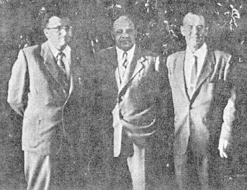

target material using carriers like zirconium phosphate, bismuth phosphate and ceric iodate. Actually, as it turned out, these separations were too slow and too inefficient. In this particular experiment, Burris and I worked about 36 hours straight doing these cycles and trying to get some-thing out that we could identify, but without success. We were extremely tired-so we went outdoors to see what the weather was like. It was dark, it was cold, it was raining and windy, and I went back to look for my coat and Burris helped me look. We searched and searched but it was in vain. Only when I finally took a look at Burris did I discover that he was wearing my coat.
"All of these things together-and I would say it was a great team effort-resulted in the final experiments that were successful. When we did them, with the help of a good many excellent people, it didn't take us more than a few minutes to be rather sure that we had climbed the mountain, so to speak. Those days in fact were very exciting and I, for one, wouldn't mind having them back."

Three more
Stan was also a leader of the research teams that discovered the next three transuranium elements, einsteinium, fermium and mendelevium (atomic numbers 99, 100 and 101). Einsteinium and fermium were discovered unexpectedly in the debris from the thermonuclear explosion (called the "Mike" event), conducted at Eniwetok Atoll in the Pacific Ocean in November 1952. Chemical identifications were made by members of the Berkeley Radiation Laboratory, the Argonne National Laboratory and the Los Alamos Scientific Laboratory during the period December 1952 to February 1953.
The discovery of mendelevium was notable in that this was the first element to be synthesized and chemically identified on a one-atom-at-a-time basis. This required all of the skill and experience that Stan had built up over the years for the use of the ion exchange adsorption-elution method for the separation and identification of actinide elements. The particular isotope of mendelevium involved decay by spontaneous fission. At about this time, a fire-bell was hung in the chemistry building, connected to the counting circuit so that a loud "clang" rang out each time one of these rare spontaneous fission events registered. However, this sport was put to a justifiable end when it came to the attention of the fire department!
We had a party celebrating the discovery of mendelevium after Stan had departed to spend a sabbatical leave under a Guggenheim Fellowship at the Nobel Institute for Physics in Stockholm. We recognized his key role in his research by providing for his presence at this party in effigy.
Stan's career was marked by a great interest in his colleagues from other countries and by his broad range of international collaboration in research. His co-workers came from countries all over the world, including Japan, France, Israel, India, and Sweden. He attended the first two Conferences in Geneva on the Peaceful Uses of Atomic Energy, in 1955 and 1958, and was quite excited to meet fellow scientists from the Soviet Union. He took his
Vitalii Goldanskii and Nikolai Perfilov (U.S.S.R.) with Thompson in Lafayette, California, July 1957

second sabbatical leave, again under a Guggenheim Fellowship, at the Niels Bohr Institute in Copenhagen where he worked with Aage Bohr and Ben Mottelson.
Although his research career, following the war, was focused on basic or fundamental science, he continued to keep an eye out for practical applications. An outstanding example of this is the development by his group of the x-ray fluorescence technique for qualitative and quantitative chemical analysis. This method has found wide application in industry and medicine and is also a powerful tool in research.
He had a long-time interest in the nuclear fission process. He and his co-workers did extensive experimental work on the mechanism of fission, often exploiting the spontaneous fission of californium-252 for this purpose. His laboratory became a source of this versatile isotope, prepared in form suitable for investigation, for laboratories throughout the world.
Beginning about 10 years ago, when prospects for the synthesis or presence in nature of superheavy elements were recognized, Stan turned his attention to the fascinating task of trying to identify such elements. They were predicted to be situated potentially in an "island of stability," centered around nuclides with atomic numbers in the neighborhood of 114 and neutron numbers around 184. Thus the chemical homologs are predicted to be as follows: 110 (Au), 111 (Pt), 112 (Hg), 113 (Tl), 114 (Pb). Stan soon turned to the task of searching for the presence of such elements in the ores of their homologs. He and his co-workers used, for example, many kilograms of gold in this quest. Basing their hopes on the predicted neutron emission in the spontaneous fission decay process, they set up their neutron detection apparatus in the tunnel bored through the Berkeley hills for the subsequent passage of BART trains. The 260 meters of overhead dirt gave a large degree of shielding from cosmic ray neutrons, thus greatly increasing the sensitivity of the neutron detection process. Unfortunately, negative results were obtained, but it was possible to set very low upper limits for the concentration of a range of superheavy elements in the ores containing their homologous elements.

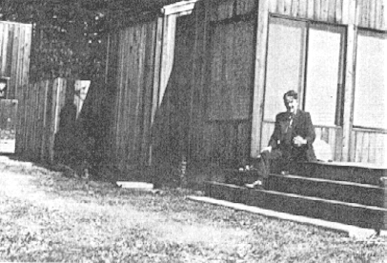
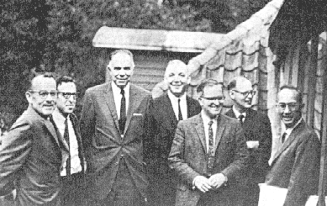
Thompson's house at The Sea Ranch on the northern California coast

At Niels Bohr institute, Copenhagen, September 20, 1966: Stanley
Thompson, Ben Mottelson, Glenn Seaborg, Arnold Fritsch, Aage
Bohr, Bent Elbek, Richard Diamond

His most recent work was in the field of heavy-ion reactions, using the SuperHILAC. The work of the Thompson-Moretto group has contributed substantially to the understanding of various reaction mechanisms, especially the "relaxation phenomena" that take place in the interesting new inelastic processes.
Among the honors that came to Stan was the American Chemical Society Award for Nuclear Applications in Chemistry.
About seven years ago, Stan and Alice built a second home at a new development, the Sea Ranch, on the Pacific Ocean about 60 miles north of San Francisco. He enjoyed its peace and quiet and intended to spend the major portion of his time there upon his retirement.
I can do no better than to close this account of the life of this remarkable chemist and colleague with a thought
expressed by Kenneth Lincoln, his son-in-law:

"I remember him as a man of courage--Wise Heart, as I thought of a Lakota name for him, Cante Ksapa. He taught me how to be patiently wise, at least to trust that one can grow into such wisdom, knowing how destructive frustration, impatience, and resentment--the angers of living--can be to knowing oneself and anything beyond. He counseled me by example.... He was a man to be liked and respected--a man of the old values, the essential and simple ways of living. Although a private man, often alone with his thoughts, he was primarily a man of good will, with many friends from all walks of life."

Author's address: Lawrence Berkeley Laboratory, University of California, Berkeley, Calif. 94720.

This article was scanned with OCR so it could be more easily indexed. The original was a photocopy provided by the American Chemical Society, publisher of the journal, Chemtech©. The exact reference is

Seaborg, G.T. Stanley G. Thompson--a chemists chemist. Chemtech, _(7):408-413, 1978

© 1978 American Chemical Society

